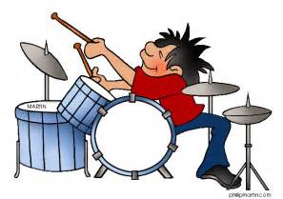

Notice for Percussion Students

Percussionists only
A Feature of the WBG Music School each year is the provision of specialised percussion tuition. Time is allocated every day to develop students’ reading skills and techniques on tuned and un tuned percussion.
In order for the school to best cater for increasing enrolment levels, all students are expected to bring their own instruments, sticks and mallets. Please note that a drum pad, snare drum (or kit) and a tuned percussion instrument (for melodic training) are the minimum requirement.
Please ensure that all of your equipment is clearly labelled with your name.

The following criteria must be met to enrol as a percussion student

- Must be 10 years and above of age
- Must have basic reading and writing skills
- Must play percussion in a band
- May be required to bring a drum kit to the Music School
- Must have at least 2 pairs of drum sticks
- Must bring a music stand
- Must bring a set of ear plugs
- A basic student model glockenspiel (with appropriate mallets) would be suitable for the tuned percussion component of the course.
- Please ensure that all of your equipment is clearly labelled with your name.

Please contact the School to enrol on admin@wbgmusicschool.com

